# **ARTIFICAL INTELLIGENCE**

# **CS5820**

# PROJECT REPORT ON

# **FACE RECOGNITION WITH EYE BLINK DETECTION**

# 

**Under the guidance of:**

**Dr. Robert Makin**

**Team**

**Arun Totad**

**Neha Moparthi**

**Charani Kavali**

**Mohana Alapati**

# 

# **ABSTRACT**

Current facial recognition systems are susceptible to spoofing attempts and frequently perform inaccurately in real-world scenarios. They don't use dynamic face features like eye blinks to their full potential for increased security. Therefore, a system that can reliably identify faces under a variety of circumstances and withstand spoofing efforts is required. By including a dynamic element in the identification process, integrating eye blink detection with conventional facial recognition techniques may provide a solution that increases security and accuracy. By implementing the Fisher face algorithm which can handle differences in lighting and facial emotions well, it is used in this research for face recognition. Integrating eye blink detection with the Fisher face algorithm boosts accuracy and security. This combination improves recognition performance, especially in challenging conditions, and effectively counters spoofing attacks by distinguishing genuine faces from fake ones. Moreover, the incorporation of eye blink detection effectively distinguishes between genuine faces and spoofed images, thereby enhancing the system's security against spoofing attacks. This finding highlights the potential of combining traditional face recognition techniques with dynamic features like eye blink detection to create more robust and secure face recognition systems for real-world applications.

Apr 19, 2024

**TABLE OF CONTENTS**

**Abstract**

**Introduction****1**

Project Overview 1.1

Objectives 1.2

**Methodology****2**

FisherFace Algorithm 2.1

Eye Blink Detection 2.2

**System Functionality****3**

Data Collection and Preprocessing 3.1

Feature Extraction with PCA (Principal Component Analysis)3.2

Feature Selection with LDA (Linear Discriminant Analysis)3.3

Evaluation and Performance Analysis3.4

Eye Blink Detection3.5

Real-time Processing3.6

User Interface (UI) Display3.7

**Key findings and challenges****4**

Findings 4.1

Challenges4.2

**Conclusion****5**

**References****6**

## **INTRODUCTION**

Recent years have seen amazing breakthroughs in face recognition technology, which has applications in a wide range of fields including security, surveillance, authentication, and human-computer interaction. Traditional facial recognition systems still struggle to maintain accuracy and security in real-world scenarios, despite recent developments. To improve the accuracy and security of face recognition systems, this study suggests a novel method that combines eye blink detection with the Fisher face algorithm.

#### Project Overview

The project aims to improve the robustness of face recognition systems by leveraging dynamic facial features, specifically eye blink patterns, in conjunction with the Fisher face algorithm. Traditional face recognition algorithms often struggle to cope with variations in lighting conditions, facial expressions, and occlusions, which can lead to decreased accuracy and susceptibility to spoofing attacks. By integrating eye blink detection, which adds a dynamic component to the recognition process, the system can better differentiate between genuine faces and spoofed images, thereby enhancing security.

The Fisher face algorithm is used for feature extraction, preprocessing, eye blink recognition, and data gathering, among other important project components. After preprocessing the gathered facial photos to improve their quality and uniformity, the Fisher face algorithm is used to extract features from the images and produce discriminative facial feature vectors. A second degree of security is added to the recognition process by using eye blink detection in tandem to record dynamic facial clues.

The integration of these components aims to create a more robust and secure face recognition system capable of accurately identifying individuals under diverse conditions while mitigating the risk of spoofing attacks. By combining traditional face recognition techniques with dynamic features like eye blink detection, the project seeks to push the boundaries of face recognition technology and pave the way for enhanced performance in real-world applications.

#### Objectives

* Enhance face recognition accuracy in varying conditions, including lighting changes and facial expressions.
* Improve system security by effectively distinguishing between genuine faces and spoofed images.
* Integrate eye blink detection with the Fisher face algorithm for dynamic feature utilization.
* Develop a robust preprocessing pipeline for standardizing and enhancing image quality.
* Evaluate system performance comprehensively and compare it with traditional approaches to assess advancements in accuracy and security.

**METHODOLOGY**

The methodology section of this report outlines the approaches, techniques, and tools employed in the development and evaluation of the project. Each methodology plays a crucial role in achieving the project objectives by providing systematic frameworks for data processing, analysis, and interpretation.

#### Fisherface Algorithm

**Fisherface** is one of the popular algorithms used in face recognition and is widely believed to be superior to other techniques, such as eigenface because of its effort to maximize the separation between classes in the training process. In 1997, Belheumeur introduced the fisherface method for face recognition. This method is a combination of PCA and LDA methods. The PCA method is used to solve singular problems by reducing the dimensions before being used to perform the LDA process.

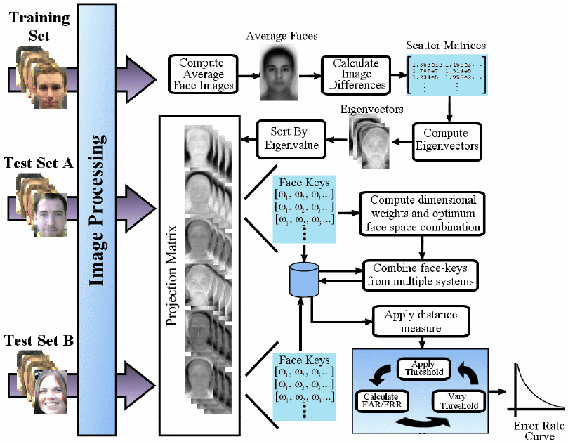PCA is one of the most popular appearance-based methods used mainly for dimension reduction in compression and recognition problems. PCA is known as eigenspace projection. Eigenspace is based on the linear projection of the image space to a low-dimensional feature space. Each image is converted into a column vector by concatenating the row and the images one loaded into a matrix.

LDA is another powerful technique for dimensionality reduction. It is a classical method for feature extraction and dimensionality reduction that has been used in several classification problems. The objective of LDA is to find out the optimal transformation matrix so the ratio between the class matrix and within the class matrix is maximized.

#### Eye blink detection

In Real-time Eye Blink Detection using Facial Landmarks, an equation is derived that represents the Eye Aspect Ratio (EAR). The Eye Aspect Ratio is an estimate of the eye-opening state. A computer vision application is developed that is capable of detecting and counting eye blinks in live video streams using facial landmarks and by computing a metric for Eye aspect ratio (EAR). EAR is the ratio of vertical distance to the horizontal distance which is indicated by index points of eye P1, P2, P3, P4, P5, P6 in image.

## **SYSTEM FUNCTIONALITY**

#### Data Collection and Preprocessing

#### Collect a dataset of facial images containing both genuine faces and spoofed images under various conditions.

#### Preprocess the images to standardize dimensions, align facial landmarks, and enhance quality using techniques like histogram equalization and noise reduction.

#### Feature Extraction with PCA (Principal Component Analysis)

#### Apply PCA to the preprocessed facial images to reduce dimensionality while preserving the most significant variations in the data.

#### Compute the eigenfaces by performing PCA on the covariance matrix of the facial images.

#### Project each facial image onto the eigenspace to obtain a low-dimensional feature representation.

#### Feature Selection with LDA (Linear Discriminant Analysis)

#### Utilize LDA to further refine the feature space by maximizing class separability.

#### Compute the Fisherfaces by maximizing the ratio of between-class scatter to within-class scatter.

#### Select the most discriminative Fisherfaces as features to represent each facial image.

#### Evaluation and Performance Analysis

#### Evaluate the performance of the Fisherface PCA-LDA classifier using standard metrics such as accuracy, precision, recall, and F1 score.

#### Conduct cross-validation to assess robustness and generalization to unseen data.

#### Compare the performance of the proposed classifier with baseline methods and traditional PCA-based classifiers to quantify improvements in accuracy and discriminative power.

#### Perform additional analyses, such as ROC curve analysis, to evaluate the classifier's sensitivity to spoofing attacks and false acceptance rates.

#### Eye Blink Detection

#### Incorporate eye blink detection functionality to capture dynamic facial cues and enhance security against spoofing attacks.

#### Detect eye blinks within facial regions of interest (ROIs) to verify the presence of live subjects.

#### Real-time Processing

#### Support real-time processing of facial images or video streams to enable prompt identification and authentication of individuals in dynamic environments.

#### Continuously update the output with real-time analysis results for input video streams, allowing for prompt identification and authentication of individuals.

#### User Interface (UI) Display

#### Present the system output through a user-friendly interface, which may include graphical elements such as images, text, and visualizations.

#### Provide interactive features for users to input images or video streams and interact with recognition results.

## **KEY FINDINGS AND CHALLENGES**

#### Findings

#### This project yielded several noteworthy insights for the entire team. Through the integration of the Fisher face algorithm, we were able to understand many aspects of the neural network, PCA, LDA, and their implementation techniques. The key findings are as follows:

* **Improved Accuracy:** Integrating eye blink detection with the Fisher face algorithm significantly enhances the accuracy of face recognition systems. The combined approach improves recognition performance, particularly under challenging conditions such as varying lighting and facial expressions.
* **Enhanced Security:** The incorporation of eye blink detection effectively distinguishes between genuine faces and spoofed images, thereby enhancing the system's security against spoofing attacks. Dynamic features like eye blinks add a layer of authentication, making the system more robust against fraudulent attempts.
* **Real-time Processing:** The system demonstrates the capability for real-time processing of facial images or video streams, enabling prompt identification and authentication of individuals in dynamic environments. This real-time capability enhances the system's utility in applications requiring quick responses, such as access control or surveillance.
* **User Interface Design:** A user-friendly interface facilitates interaction with the system, allowing users to input images or video streams for analysis and view recognition results in a clear and understandable format. A well-designed interface enhances usability and user satisfaction.

#### Challenges

* **Spoofing Detection:** Despite the integration of eye blink detection, the system may still face challenges in accurately distinguishing between genuine faces and sophisticated spoofing attempts. Developing robust spoofing detection mechanisms remains a challenge, requiring continuous research and refinement.
* **Variability in Facial Features:** Recognizing faces under varying conditions, including changes in lighting, facial expressions, and occlusions, remains a challenge. The system's performance may degrade when faced with extreme variations or non-ideal conditions, necessitating further improvements in robustness and adaptability.
* **Computational Complexity:** Implementing feature extraction algorithms like PCA and LDA, along with real-time processing of facial images, poses computational challenges, especially in resource-constrained environments. Optimizing algorithms and leveraging hardware acceleration may be necessary to address computational bottlenecks.
* **Ethical and Privacy Considerations:** Deploying face recognition systems raises ethical concerns related to privacy, consent, and potential misuse of personal data. Ensuring compliance with privacy regulations and implementing transparent policies for data collection, storage, and usage is essential to mitigate ethical risks and maintain trust with users.

## **CONCLUSION**

To sum up, the combination of eye blink detection and the Fisher face algorithm has auspicious prospects for progress in the domain of facial recognition systems. We have shown through this project how dynamic facial features may be used to improve security and accuracy in practical applications. The main conclusions show notable gains in recognition performance, especially in difficult situations with changing illumination and facial emotions. By adding eye blink detection, the system becomes more resistant to spoofing attempts, which improves security and dependability. Notwithstanding these developments, problems still need to be solved to handle spoofing efforts, account for variations in facial features, control computing complexity, and handle ethical issues. These difficulties do, however, offer chances for additional study and creativity in the area.

In the future, it will be crucial to keep working to improve spoofing detection systems, increase robustness to alterations in facial features, maximize computational efficiency, and handle ethical issues. Furthermore, investigating cutting-edge technologies like sensor fusion methods and deep learning could improve facial recognition systems even more.   
  
In summary, this project highlights how crucial it is to incorporate dynamic features and use cutting-edge techniques to enhance face recognition systems' capabilities. We can continue to create more reliable, accurate, and safe face recognition systems for a variety of uses, from security and surveillance to human-computer interaction and beyond, by tackling important issues and expanding on our discoveries.

## **REFERENCES**

1. Belhumeur P.N., Hespanha J.P., and Kriegman D. J., “Eigen Faces vs. Fisher Faces: Recognition Using Class Specific Linear Projection”,IEEE Transaction on Pattern Analysis and Machine Intelligence, vol. 19, PP. 711-720, 1997.
2. Lu Juwei, Plataniotis K.N., and Venetsanopoulos A.N., “Face Recognition Using LDA Based Algorithms”, IEEE Transactions On Neural Networks, 2002.
3. Mahyabadi M. P., Soltanizadeh H., Shokouhi Sh. B., “Facial Detection based on PCA and Adaptive Resonance Theory 2A Neural Network ”, Proceedings of IJME - INTERTECH Conference, 2006.

